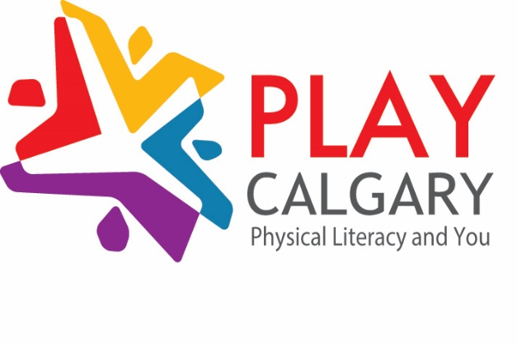

AGENDA
November 29, 2017, 1 – 3 pm
YMCA Child Development Centre (Quarry Park)
10702 18 St SE, Calgary, AB
- Welcome & Introductions
- Terms of Reference Update (Lynn Jobe)
- Knowledge Sharing
  - Vivo 4 in 1 Program presentation and questions
- Information Sharing
  - Meetings & PL Connect
- Networking
- Next Meeting: February 7th 1 – 3 PM, St. Paul Centre
If you would like to present at a PLAY Calgary meeting, please email Leah Yardley: leah.yardley@ucalgary.ca

